Do Social Media Users Interact More with Fast Food or Healthy Food Online?

David D Berberena

Bellevue University

DSC 500 Introduction to Data Science

Nasheb Ismaily

September 17, 2023

Do Social Media Users Interact More with Fast Food or Healthy Food Online?

I’d like to explore the topic of what social media users tend to share their reactions about most readily: food. More specifically, social media users are drawn towards fast food options as well as healthy food options. Now there are many ways to quantify this topic, and throughout my research, I will be sharing what evidence I have gathered through data collection, sifting, and modeling. Let us dive into the world of social media and food.

# Social Media and Food Awareness

Broaching the topic of social media users being very outspoken about their food preferences through likes, swipes, double-taps, and more begs many questions. Some inquiries are more intricate than others. Five potential research questions in direct correlation to the above topic are:

1. Do stereotypes concerning certain foods (fast or healthy) negatively impact social media activity centered around food?
2. Where in the world are online users classified as generally drawn more towards fast food as opposed to healthy food options?
3. Are there specific cuisines that are deemed “healthy food” or “fast food” by individuals that could influence their interaction with food-centric material on social media?
4. Does cyberbullying adversely skew the data that can be derived from social media giants like Facebook, Twitter, Instagram, Tik Tok when it comes to food-related posts and the user’s hesitancy to share their true feelings regarding their food category of choice for fear of fat/body shaming or other forms of online ridicule?
5. What demographic of people do we see interacting with fast food and healthy food respectively via social media?

## Summary of Research Findings

Google Trends has allowed me to look further into the second of my five questions, as the search engine can show where in the world fast food is more popular amongst residents of the country than healthy food and vice-versa, expressed in different figures. Below are a few visuals to illustrate my findings.

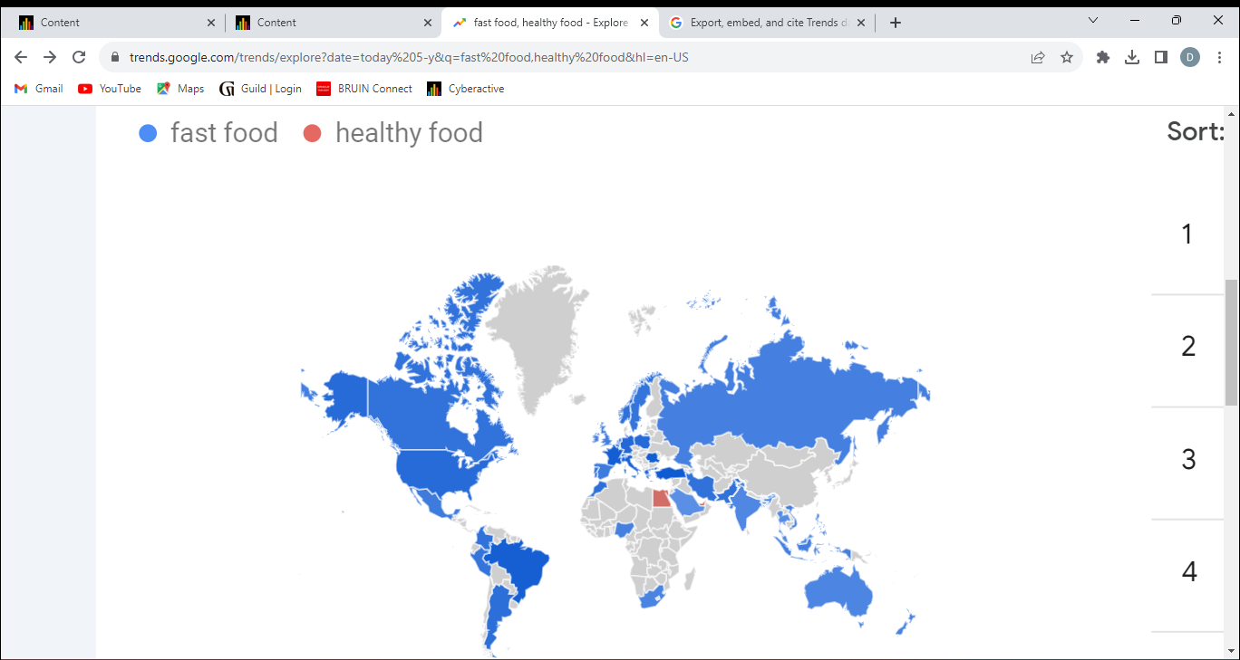

This map provided by Google Trends (n.d.) shows the comparable popularity of “fast food” searches and “healthy food” queries worldwide for the past five years. Only three countries (Egypt, United Arab Emirates, and Singapore) are shown to have a higher percentage of “healthy food” searches, while all of the blue-colored countries have a higher percentage of “fast food” searches.

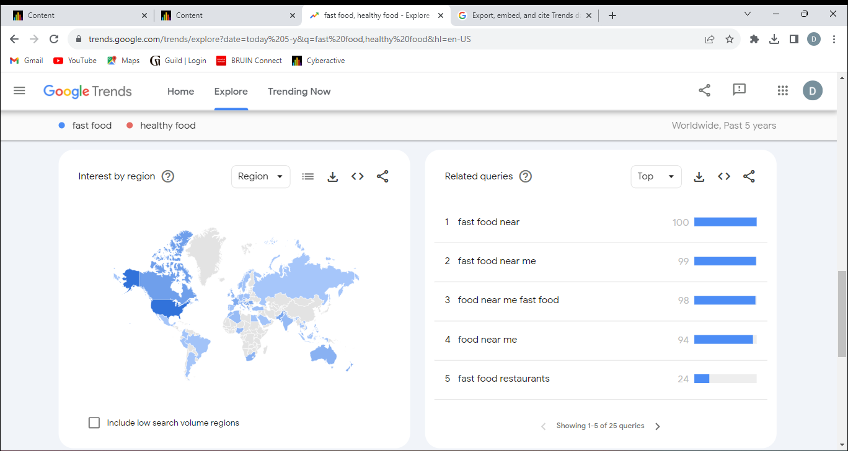

The next visual pictured above shows the most popular “fast food” searches in relation to one another on the right-hand side of the photo. The left side shows the world map with the blue “fast food” search countries in different shades of blue, signifying how popular “fast food” searches are in that location as a fraction of overall popularity between countries.

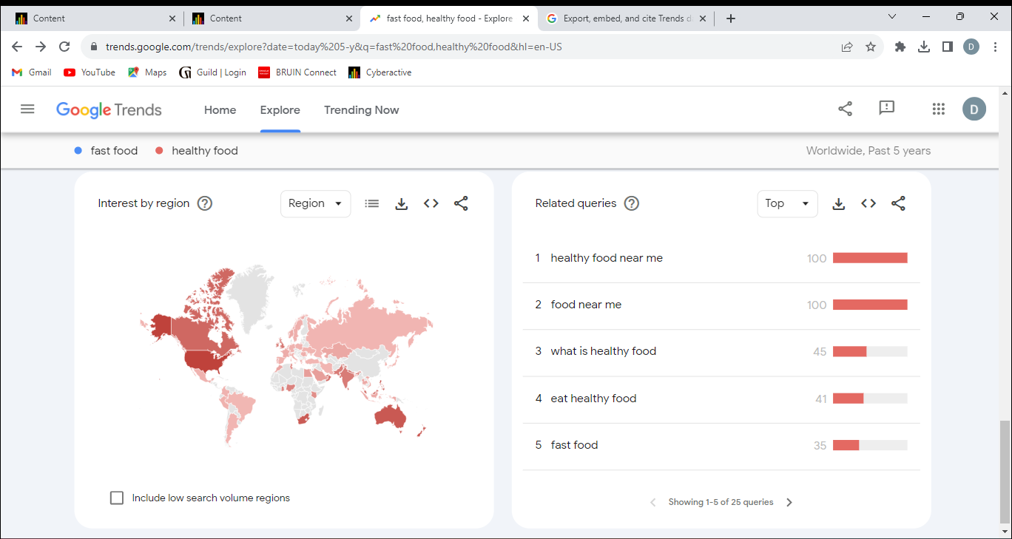

This visual pictured above illustrates the same concepts as the previous map except now with the “healthy food” searches and popularity.

### Conclusion

The visuals depicted show that while most of the world is definitely focused on both fast food and healthy food, as evident in their Google search behavior, there is a clear indicator that almost every country that is involved with this data skews towards searches involving fast food much more. Take the United States for a more in-depth example. According to Google Trends (n.d.), the United States shows an interest in fast food much more than in healthy food, with 82% of the combined term searches being solely “fast food” searches. However, both searches are asking the same question by users: where can they obtain those foods near them?

The next order of business will be to peruse data pertaining to the demographic of social media users interacting with fast food and healthy food online. We now know that there are plenty of people interested in searching for both categories, so we need to eventually identify these people to know exactly the kind of users who like that Salt Bae video on Instagram, or who frequent the Heart Attack Grill Twitter page, or even who comment their support on a Facebook post outlining alternative healthy ways to make unhealthy sweets. Understanding these social media users on a more data-driven level will help see how they currently interact with these foods and posts online, and potentially guide us into predicting how these users will interact with future, unpublished foodie media.

References

Google Trends (n.d.). "Fast Food, Healthy Food". Retrieved September 16, 2023, from https://trends.google.com/trends/explore?date=today%205-y&q=fast%20food,healthy%20food&hl=en-US